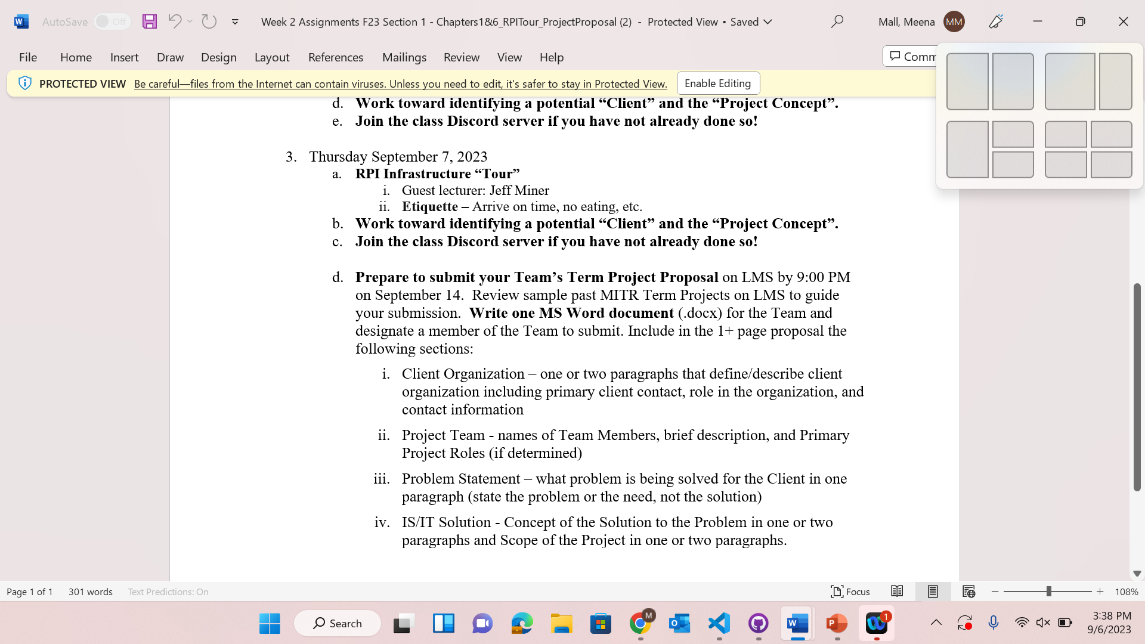

***Project Proposal:***

**Part 1:**(Client Organization)

The RCC is looking for a group to develop a suite of web applications to further our growth of the RPI CTF teams and our cybersecurity research. This suite has three applications:

A public-facing website highlighting the successes of the RCC, profile pages for core faculty and students, calendar of events, and alumni engagement. Among other design elements, a logo for the RCC needs to be created, and needs to be approved by the powers-that-be. The site needs to be attractive to potential donors and sponsors. The site will need to adhere to RPI web accessibility guidelines and RPI branding guidelines.

A knowledge management system that enables quick and easy searching of CTF writeups. This application should allow for login, and after logging in allow users to search through a database of CTF writeups, organized by date, competition, and category of exploit, and display writeups selected by the user. The system must enable easy upload of future writeups; writeups may include any or all of text, images, video, audio, source code, exploit code, and binaries. A small example of 10 write ups are available as test data.

A frontend to a custom CTF backend. This frontend should be able to draw challenges from the custom backend and present the user with interactive modules similar to the open source project Ghidra. This frontend should be able to grab a challenge from a database of challenges, place the challenge binary into memory. Modules include the display of the original source code, the compiled assembly of the original source code, a control-flow navigator, a Python script interpreter for inputting exploits into the binary, and a gdb-compatible debugger that is automatically hooked up to the binary. All challenges conclude with the capturing of a “flag,” and the user needs to be made aware when a flag has been captured. The backend already exists, and can be shared.

The RCC is the Rensselaer Cybersecurity Collaboratory. It currently serves as the main cybersecurity research center and club at RPI. The RCC researches a wide range of cybersecurity related topics and competes in various CTFs. Our point of contact for the RCC is Dr. Callahan. He serves as the Director for the RCC. His email address is [callab5@rpi.edu](mailto:callab5@rpi.edu).

**Part 2:**(Project Team)

**Christopher Reed:**

Chris Reed is the Lead Backend Developer and Client Liaison. As the Lead Backend Developer, he oversees the project's development, ensuring that each technical aspect operates according to plan. Additionally, Chris takes on the crucial role of Client Liaison, serving as the primary point of contact with the client. His responsibilities include comprehending the client's demands, catering to those needs, and maintaining effective communication throughout the project.

**Meena Mall:**

Meena Mall serves as the Project Manager and the Project Designer. Her various responsibilities include understanding the client's needs, coordinating the project team, tracking progress, and guaranteeing quality. Meena oversees the project's numerous aspects to ensure its successful completion. As the Project Designer, she contributes to the visual and creative elements, while also integrating client feedback and playing a critical role in achieving the project objectives.

**Benjamin Manicke:**

Ben Manicke is the Lead Frontend Developer as well as the Lead Writer. Ben's responsibilities as the Lead Frontend Developer involve developing user-facing elements to improve the interactive user experience as well as performing extensive accessibility testing to ensure our website is accessible to all users. As the Lead Writer, he contributes valuable written content, delivering informative and engaging materials for the project.

**Terry Lin:**

Terry Lin takes on the role of Fullstack Developer. Terry's skill in both frontend and backend development is essential for the project's technological solutions. His responsibilities include coding, debugging, and ensuring the project's performance and functionality.

**Raphael Chung:**

Raphael Chung is our Fullstack Developer, in charge of developing a unified and integrated system. His responsibilities include developing and building both front-end and back-end components in order to provide an engaging user experience. Raphael also assists the Lead Writer with reports and other written materials, providing research and writing skills.

**Part 3:**(Problem Statement)

The challenges at hand stem from a series of critical issues within the RCC community. Firstly, RCC currently lacks a public-facing website, hindering its ability to attract potential donors and maintain alumni engagement effectively. In today's digital era, where individuals rely heavily on the internet for information and engagement, the absence of a public-facing website puts RCC at a disadvantage compared to peer institutions that have leveraged the power of online platforms to foster alumni connections, attract potential donors, and showcase their achievements. Secondly, while actively participating in various cybersecurity competitions, RCC faces a gap in providing students with a centralized platform to store and access their CTF writeups. Failing to provide a platform to store CTF wrtieups can limit the knowledge retention of students and hinder their ability to share the challenges with others. Lastly, there is an absence of an accessible and cost-effective CTF platform for students to enhance their cybersecurity skills through practical challenges. With the growing demand for cybersecurity expertise in today's digital landscape, the absence of an accessible and budget-friendly Capture The Flag platform deprives students of a valuable hands-on learning opportunity crucial for honing their cybersecurity skills.

**Part 4:**(IS/IT Solution)

There are three parts to our project:

1. We will first focus on creating a website that will be the public face of RCC to potential donors, sponsors, and recruits. We will include in the website a calendar of events, profile pages for members of the RCC, and alumni engagement among other things.
2. We will then create a database that will hold CTF writeups that are uploaded through the frontend into the database. The frontend will also allow users to search for write ups inside the database and be able to read/watch it.
3. Finally, we will create an interactive website that pulls from a custom CTF backend where we will display challenges for the members to solve and train on. It will utilize multiple interactive modules to help simulate the tools needed for CTF.

SUGGESTIONS:

* This should be way more detailed. One-two paragraphs on concept and one-two paragraphs on scope. Literally just rewrite the statements given to us.